

100 DAYS RTL PART-1

Day 41: VECTOR SWAPPING

Day 42: VECTOR SLICE ASSIGNMENT

Day 43: JOHNSON COUNTER

Day 44: CLOCK DIVIDER

Day 45: RING COUNTER

Day 46: PARITY GENERATOR

Day 47: N-BIT COMPARATOR

Day 48: BI-DIRECTIONAL SHIFT REGISTER

Day 49: MASTER SLAVE JK FLIP FLOP

Day 50: MOORE FSM 1010 SEQUENCE DETECTOR

Day 41: Vector Swapping

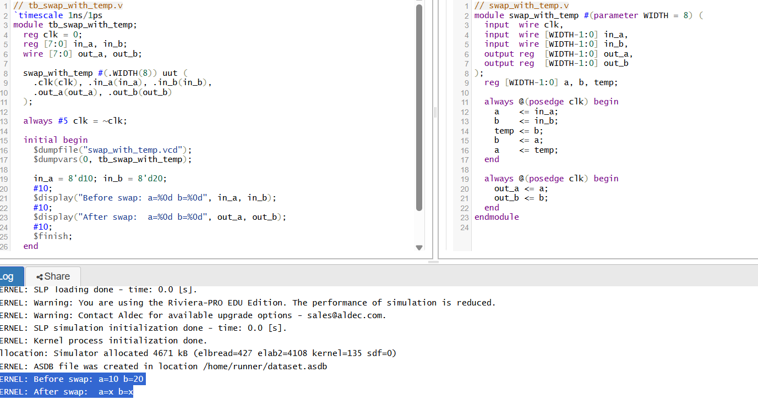

🧠 1. Blocking (=) vs Non-Blocking (<=) Assignments
🔹 Blocking (=)
- Sequential execution within an always block: each statement completes before the next one starts
- Immediate update: RHS is evaluated and LHS is updated instantly.
- Useful for combinational logic, not recommended for sequential/clocked logic

🔹 Non-Blocking (<=)
- Parallel scheduling: RHS values are captured at the time-step start; LHS updates occur together at the end
- Ideal for sequential, clocked logic
- For swapping:
🔄 2. How Input Handling Works in the Swap
- With non-blocking, both inputs (a, b) are sampled at the same time at the clock's rising edge. There is no intermediate overwrite, so the transfer is reliable.
- With blocking + temp, b is saved first, then swapped—so the input to every subsequent stage is explicitly controlled and temporally ordered.
⏱️ 3. Timing Semantics and Race Avoidance

- Blocking operations occur immediately and sequentially, so the order of statements matters—this can cause unintended feedback or race conditions if used wrongly in sequential logic.
- Non-blocking ensures that all registers update in lockstep at the end of the cycle. This prevents races and reflects actual hardware—flops only change on clock edges
- Rule of thumb:
  - Use <= in clocked always blocks (sequential hardware).
  - Use = in combinational always blocks (always @*)

Day 42: Vector Slice Assignment:
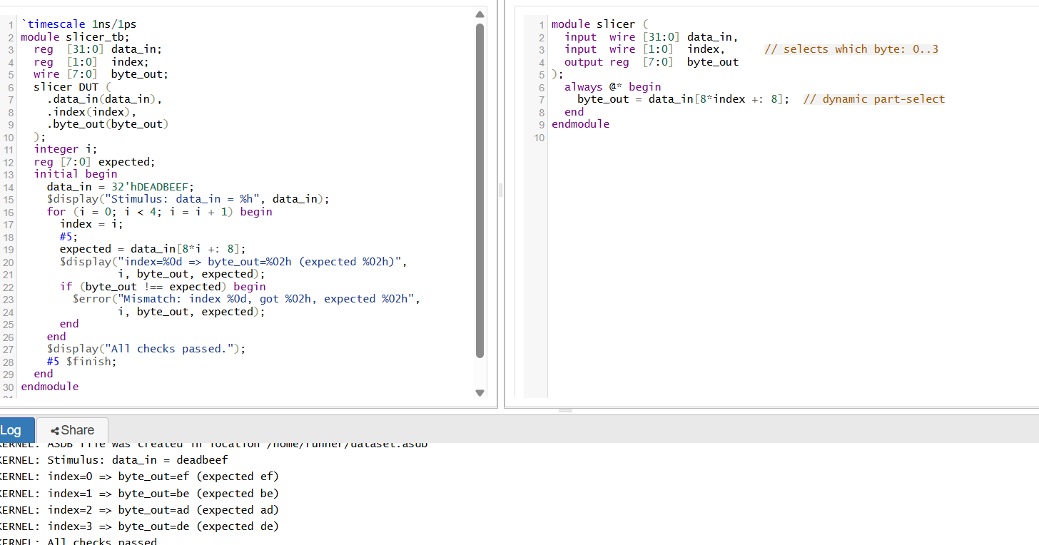
📚 Theoretical Notes (with code mapping)
- Indexed part-select:
Uses the form [base +: WIDTH] to extract WIDTH bits beginning at base (where base = 8 * index, and WIDTH = 8).
This avoids illegal dynamic-range errors like [8*i+7: 8*i], which synthesizers reject
- Constant width requirement:
The width (8 here) must be a compile-time constant. Only base (i.e., 8*i) may be a runtime expression.
- Self-checking testbench:
Compares DUT output (byte_out) against a computed expected value and raises an error if they don't match — a recommended best practice

Day 43: Johnson Counter
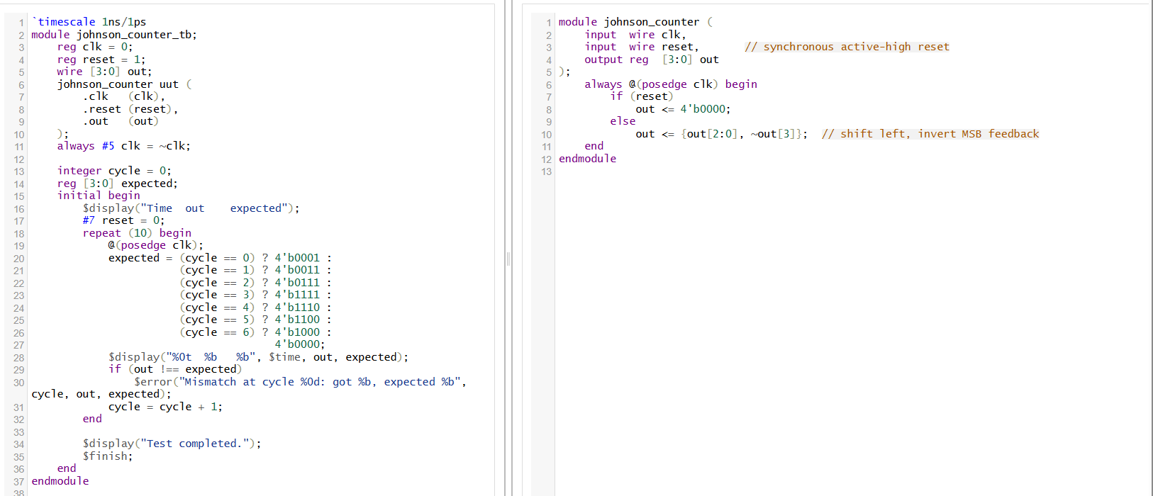

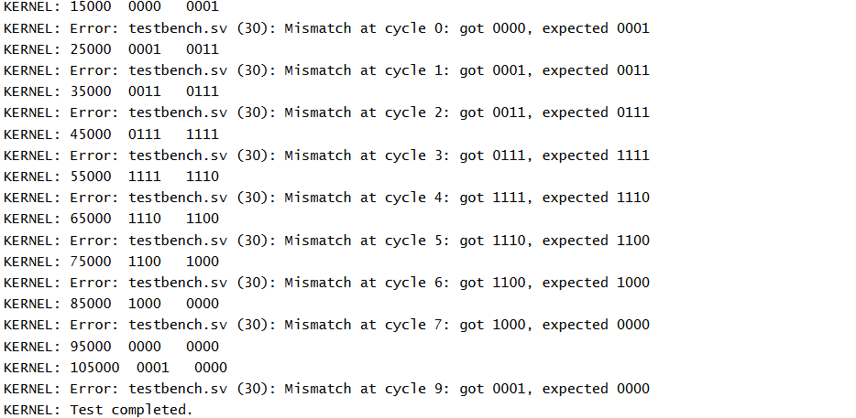
🧠 What Is a Johnson Counter?
A Johnson counter, also called a twisted ring, creeping, or switch-tail counter, is a synchronous shift-register counter. It consists of n flip-flops in series, with the inverted output of the last stage (Q̅ₙ) fed back into the input of the first stage (D₁)
⚙️ Core Operation & State Sequence
- Initialization: Typically starts at all-zero state (e.g., 000...0).
- Feedback: On each rising clock edge, bits shift right, and the inverted last bit cycles in at the leftmost stage .
- Sequence (n=4 example):
0000 → 1000 → 1100 → 1110 → 1111 → 0111 → 0011 → 0001 → 0000 …
Produces 2n distinct states (here, 8 states) before repeating
🔢 Counting Capacity and Modulus
- Modulus: A Johnson counter with n flip-flops has a mod-2n cycle (i.e., 2n states)
- Efficiency: Uses the same hardware as a ring counter but offers double the state count
- Unused States: Though the flip-flop array is 2ⁿ in capacity, only 2n states are employed, leaving many invalid/unreachable states.
✅ Advantages
- Hardware-efficient
- Self-starting
- Gray-like transitions
- Self-decoding

Day 44: Clock Divider
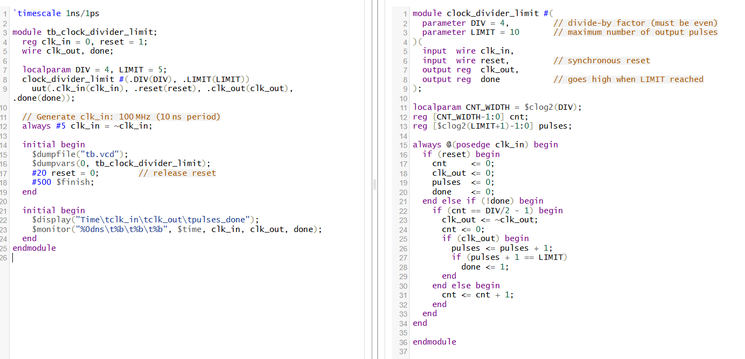
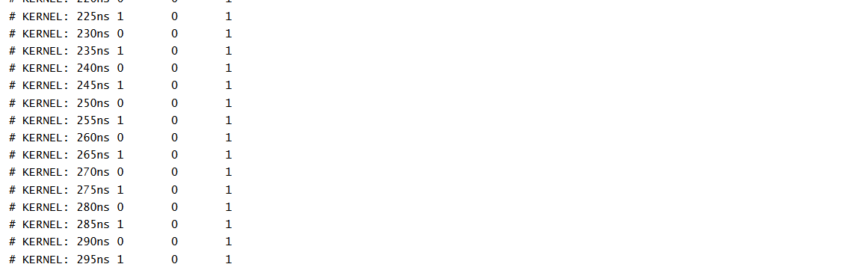
How it works:
- A counter (cnt) toggles clk_out every DIV/2 cycles for a 50% duty cycle.
- Each rising edge of clk_out increments pulses.
- When pulses hits LIMIT, the done signal asserts and division stops.
This approach is based on standard divider practices like “toggle on half count”
Testbench summary:
- Applies reset at start.
- Uses a 100 MHz input clock.
- Monitors clk_out and done signal.
- Simulation ends after 500 ns, enough time to observe the 5 output pulses.
🔍 Explanation & References
- Using a counter + toggle is a well-known technique for generating a 50% duty-cycle divided clock.
- The done flag adds a useful output limit, handy for generating a fixed number of pulses (e.g., finite-state control, timed operations).

Day 45: Ring Counter
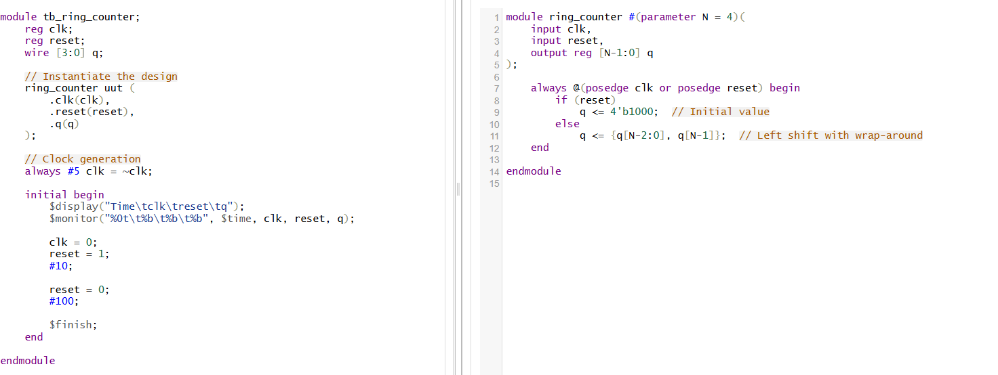
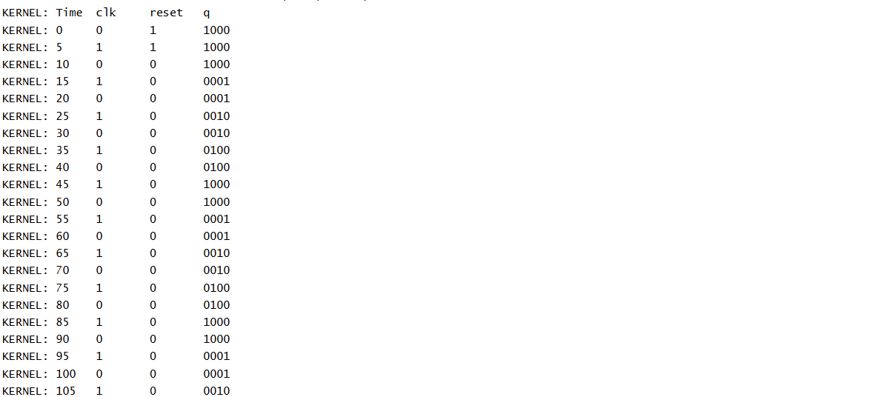
🔍 What is a Ring Counter?
A Ring Counter is a type of shift register where the output of the last flip-flop is connected back to the input of the first flip-flop. It circulates a single 1 or 0 through the register bits in a circular fashion.
🔁 Working Principle:
- It’s an n-bit shift register where only one flip-flop is set to 1 at a time, and this 1 circulates with every clock pulse.
- For example, a 4-bit ring counter will go through:
1000 → 0100 → 0010 → 0001 → 1000 → ...

🧠 Design Explanation:
We use:
- A clock and reset
- A register to store the current state
- On reset: initialize to 1000
- On every rising edge of clock: shift left and wrap the MSB to LSB
Day 46: parity generator
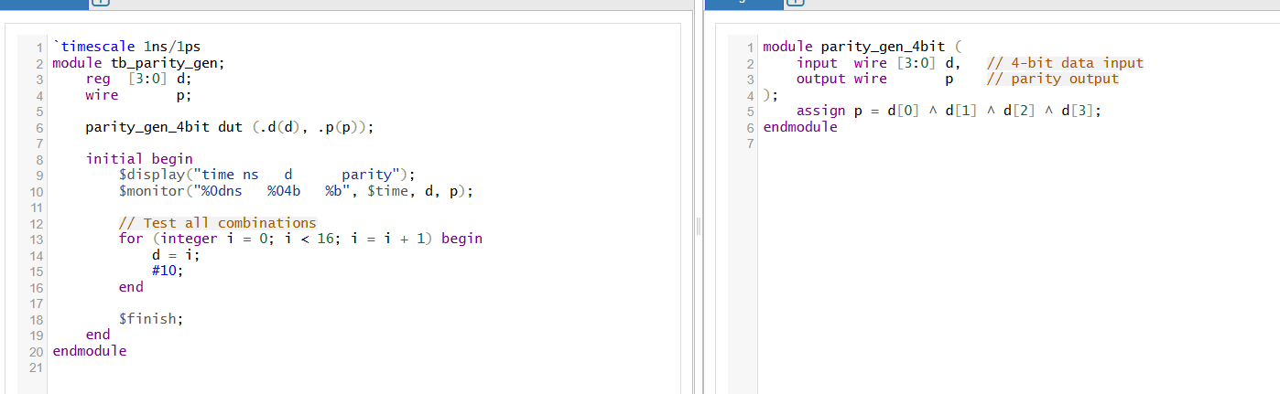
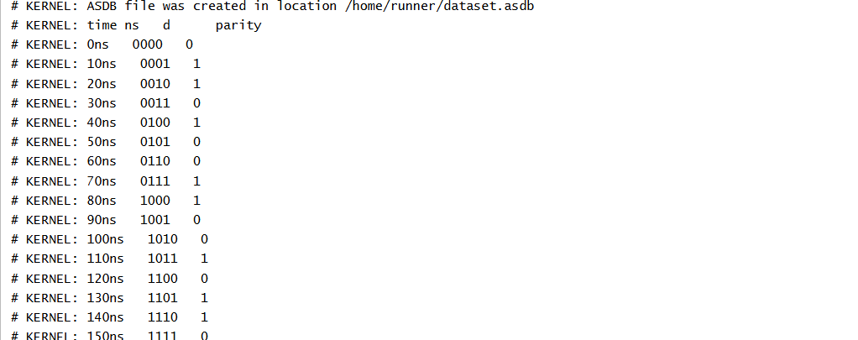
1. Design: 4-bit Even Parity Generator
A parity generator outputs one extra bit so that the total number of 1’s (data + parity) is even. The logic is just the XOR of all data bits:
✅ 3. Why It Works
- XOR across bits yields 1 if an odd number of inputs are 1, else 0.
- For even parity, that value is exactly the bit needed to make the total count even.
- The testbench confirms behavior across all combinations.
- Parity checker is similar — XOR all bits including the received parity bit, and an error is signaled if the result is not zero for even parity.
- 2D parity (row+column) is more advanced.
TL;DR Summary
Module | Key Logic
parity_gen | p = XOR of all data bits
tb_parity_gen | loops through data; displays parity
- Even parity: p = ^d[7:0]
- Odd parity: p = ~(^d)
- Checker: XOR of data + parity should_be 0 → OK; else error.

Day 47: N-bit comparator
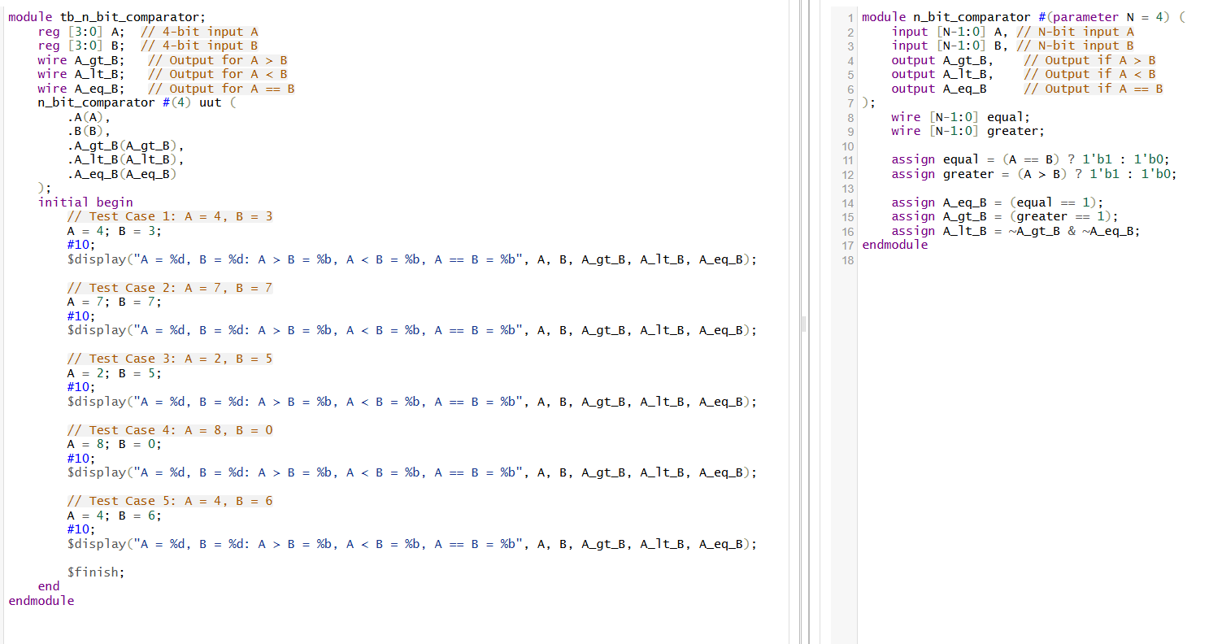

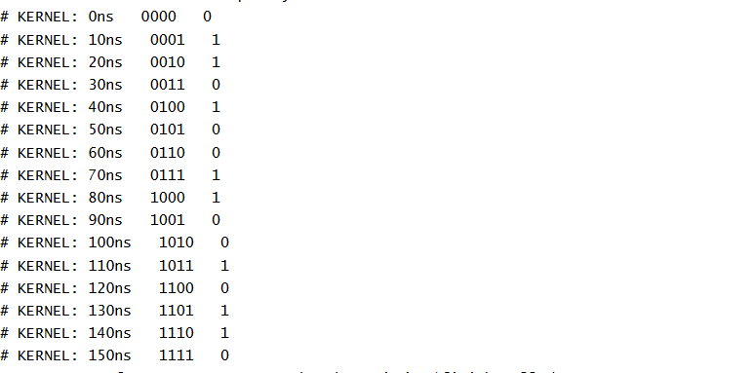
A N-bit comparator compares two binary numbers and returns outputs based on their relative magnitude. The basic design involves comparing each bit of two N-bit numbers in a pairwise manner, generating outputs for whether the numbers are equal, or if one is greater than the other.
N-bit Comparator Design
The design of an N-bit comparator can be broken down into several parts:
- Inputs:
  - Two N-bit numbers, A[N-1:0] and B[N-1:0].
- Outputs:
  - A > B (1 bit) - High if A is greater than B.
  - A < B (1 bit) - High if A is less than B.
  - A == B (1 bit) - High if A is equal to B.
- Logic:
  - For A == B, check if each bit of A equals the corresponding bit of B from MSB to LSB.
  - For A > B, propagate a "greater than" flag whenever a higher bit in A exceeds B.
  - For A < B, similarly, propagate a "less than" flag when a lower bit in A exceeds B.
Explanation of Testbench:
- The testbench is designed for a 4-bit comparator (N = 4).
- Several test cases are applied, comparing different values for A and B to verify the correctness of the comparator.
- Each test case is followed by a delay (#10) to allow the signals to propagate before printing the results.
- The $display statement outputs the results of the comparison (A > B, A < B, A == B).
Day 48: Bi-Directional Shift Register
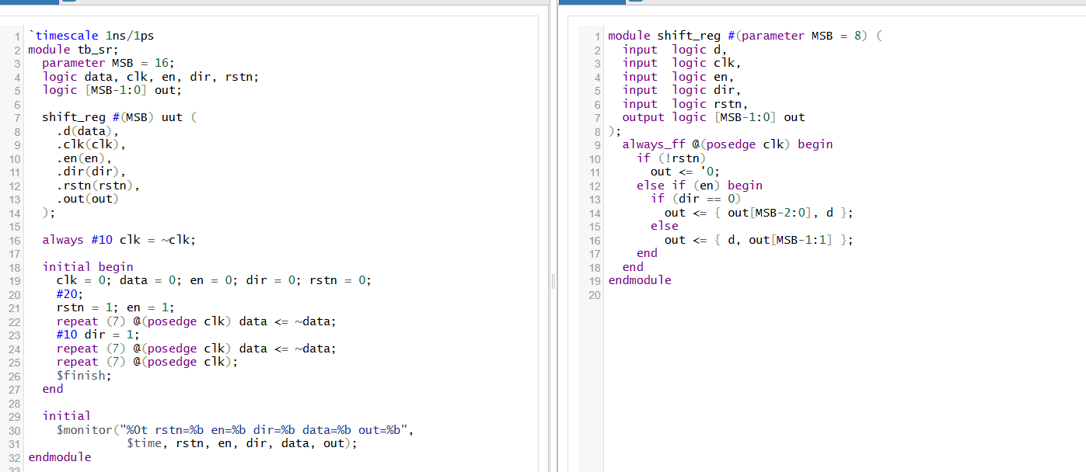
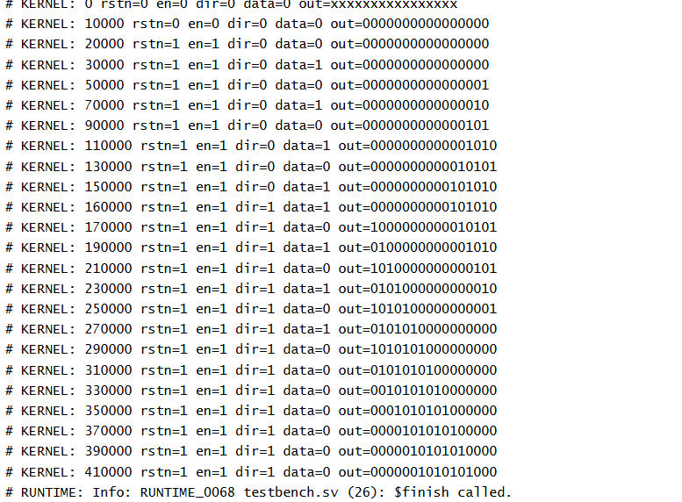

• MSB selects width (e.g., 8 or 16).
• On each posedge clk:
- If reset low: out <= 0
- Else if enable high:
  - dir == 0: shift left → out <= {out[MSB-2:0], d}
  - dir == 1: shift right → out <= {d, out[MSB-1:1]}
- If enable low: maintain current state .
This TB:
- Resets the design
- Enables shifting
- Flips input data,
- Switches direction halfway,
- Observes output behavior .

✅ Key Takeaways
- Parameterized width via parameter MSB
- Control signals: en and dir
- Serial behavior: serial-in, serial-out shifting
- Reset logic for clean simulation starts
- Directed testbench monitors functionality across modes

🛠️ How to Verify & Extend
Task | Tip
Validate waveforms | Run TB in simulation tool and observe shifting bits
Extend width | Change MSB parameter to 4, 8, 16, etc.
Add parallel load | Enhance with load control and load_data input
Add serial outputs | Provide msb_out, lsb_out for convenience

Day 49: Master Slave jk flip flop

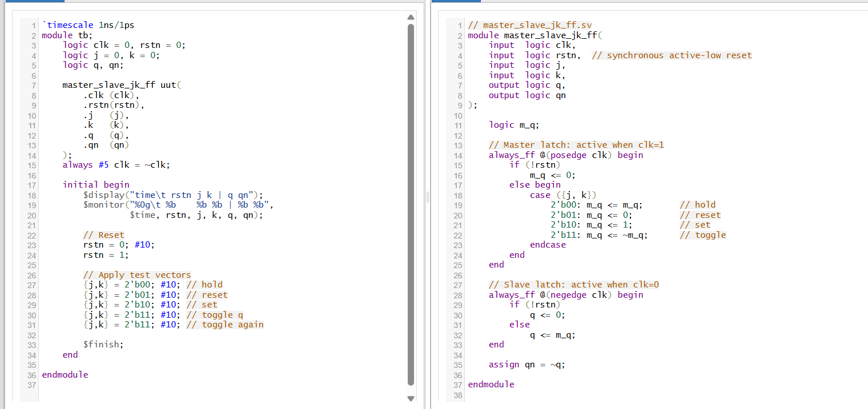
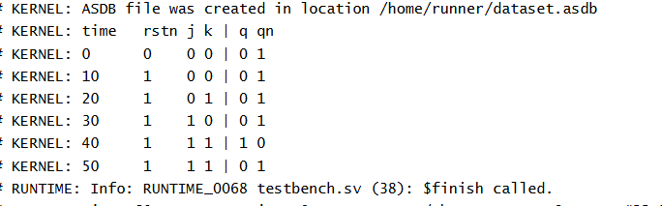
🔁 1. Master–Slave JK Flip-Flop: Concept & Working
- Structure: Two latches in series:
  - Master latch: operates when clock = 1
  - Slave latch: operates when clock = 0 (driven by inverted clock)
- Why it's used: Prevents the race-around condition seen in simple JK flip-flops when J = K = 1 and the clock is held high—this configuration ensures toggling only occurs across a full clock pulse.
- Truth Table:
J | K | Qₙ₊₁ | Action
0 | 0 | Qₙ | Hold
0 | 1 | 0 | Reset
1 | 0 | 1 | Set
1 | 1 | ¬Qₙ | Toggle
- Timing:
  - During clock high, the master latch captures J/K inputs, the slave is inert.
  - When the clock falls, the slave latch transfers the master's output to Q, completing one full cycle of behavior
Why this works:
- Master latch follows J/K behavior during clock high.
- Slave latch transfers stable master output during clock low, avoiding toggling loops
What it verifies:
- Correct reset behavior.
- Covering all input states: hold, reset, set, and toggle.
- Observes correct edge sequencing with two-phase latch

Day 50: Moore FSM 1010 Sequence Detector
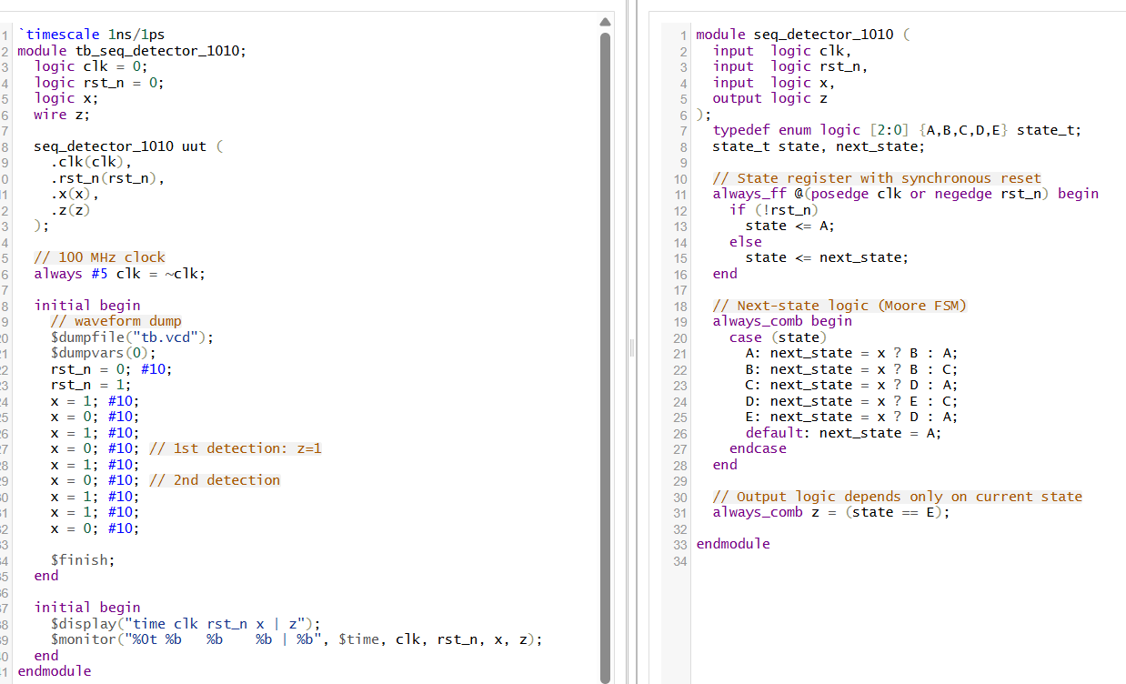
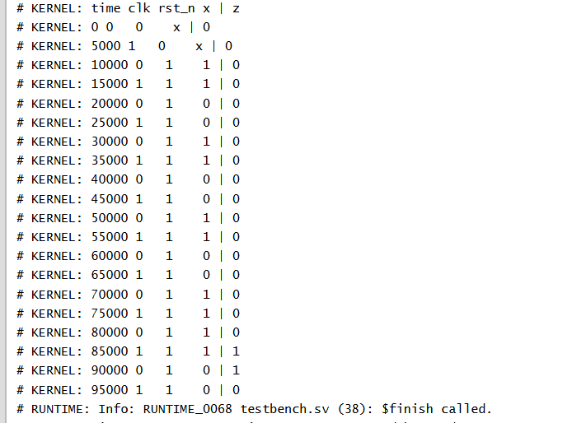

🧠 1. Moore FSM Design for “1010” Detector
- Moore machine: Output depends only on the current state (not directly on inputs).
- Detects overlapping patterns (when final bits of one detection can start the next).
- Requires 5 states—one extra state to generate the output pulse correctly
🧭 State Diagram & Naming
State | Meaning | Transition on x=1 | Transition on x=0 | z output
A | Start / no match yet | → B | → A | 0
B | Saw 1 | → B | → C | 0
C | Saw 10 | → D | → A | 0
D | Saw 101 | → E | → C | 0
E | Detect “1010” (output state) | → D | → A | 1
- State E is the output state (z=1), and from there:
  - On x=1: transition to D to allow overlapping (last 1 may start new sequence).

  - On x=0: go back to A.

- state_t is a 3-bit enum type for clarity.

- always_ff captures and resets the FSM state.

- always_comb handles both next-state and output logic.

- Output z is high only in state E.

- Clock toggles every 5 ns.

- Reset pulse held low for 10 ns.

- Applies a test sequence that includes overlapping “1010” patterns.

- Outputs monitoring shows when z pulses for detections.



